Kenji776 3rd Party Login Service

This class contains two RESTful methods. The first is a get method for getting the Salesforce username and Id of a user object based on their 3rd party username and 3rd party service name. It will find any user with a matching Third_Party_Account__c (specified in the request as ‘service’) and Third_Party_Username__c (specified in the request as ‘username’).

The second method is for updating a user’s Third_Party_Account__c and Third_Party_Username__c. In the request specify a username, service, and then either a sfusername or sfuserid (or both). This information will be used to update a user object that matches on either the sfusername or sfuserid.

Both methods return a similar data object (in your preferred format of JSON or XML). They will contain the following information.

1. Success: a flag indicating if the operation completed successfully
2. Message: a human readable string indicating the result of the operation, or error details
3. SFuserId: the Id of the user record that was read or modified
4. SFusername: the username of the user record that was read or modified
5. Service: the current Third_Party_Account__c on the user object
6. Username: the current Third_Party_Username__c on the user object

Using either method couldn’t be easier. Simply install the class into your org. By default it will be listening at

<https://[yourInstanceNumber].salesforce.com/services/apexrest/v.9/login>

but this can of course be changed. Authenticate with oAuth and being querying and updating by passing the parameters outlined above in the URL arguments.

Example Request - Get

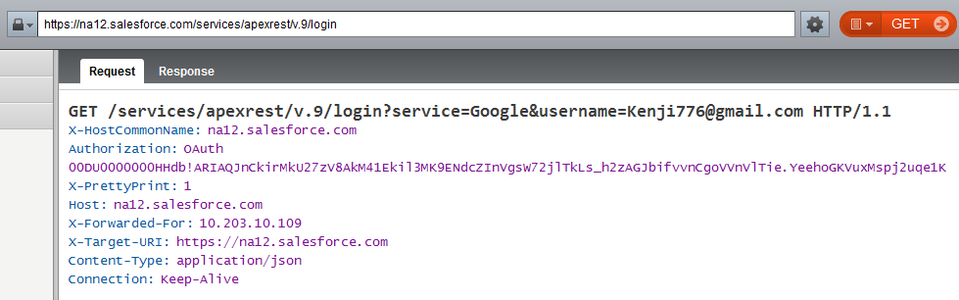

Example Response - Get

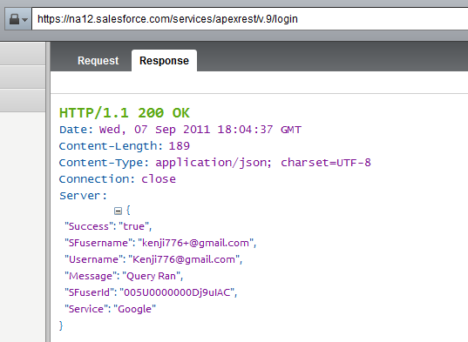

Any and all errors are handled gracefully via setting the success flag to false, and providing further details in the message field. Your application can leverage this to provide a professional user experience even in the event of a failure.